1,5 kW 3500 rpm PMSM Motor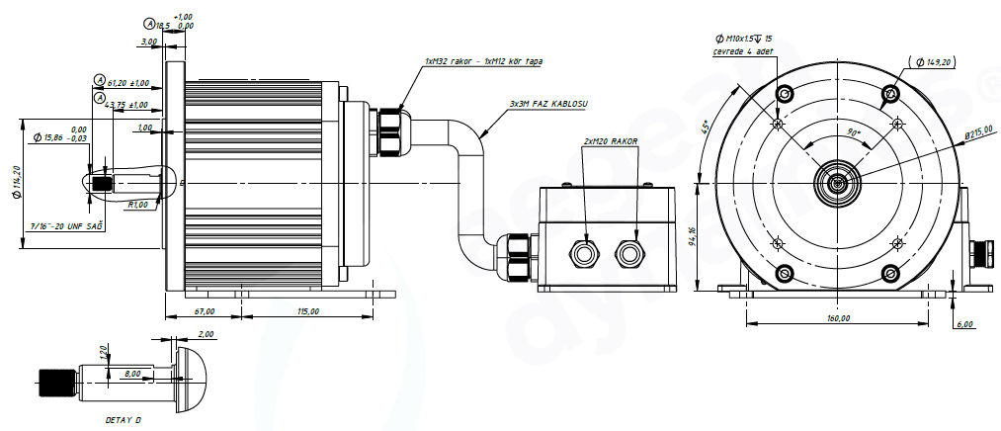
Basic Motor Parameters
Rated Power | W | 1500
Rated Speed | rpm | 3500
Rated Torque | Nm | 4.12
Rated Current | A | 85
Rated Voltage | V | 24
No-Load Speed | rpm | 3700
Max. Efficiency | % | 83
Electrical Parameters
Number of Phases |  | 3
Number of Poles |  | 10
Torque Constant (KT) | Nm/A | 0.049
Back EMF Constant (KE) | Vs/rad | 0.062
Terminal Resistance Phase to Phase (±%10) | mΩ | 2.75
Terminal Inductance Phase to Phase (±%30) | mH | 10
Thermal Data
Ambient Temperature | °C | -25...+60
Max. Winding Temperature | °C | +155
Physical Parameters
Outer Diameter | mm | 215
Shaft Diameter | mm | 7/16"-20 UNF
Max. Lenght | mm | 280
Weight | gr | ~14000
Motor Connection
U | BLACK CABLE
V | BLACK CABLE
W | BLACK CABLE
Sensor Connection
N/A | N/A
Connector Articles
Power | N/A
Signal | N/A

